Howa Mini Action 6 ARC Review
The Legacy Sports International Howa brand is well known for its value. Today we bring you a review and field test of the Howa Mini Action rifle chambered in 6 ARC.
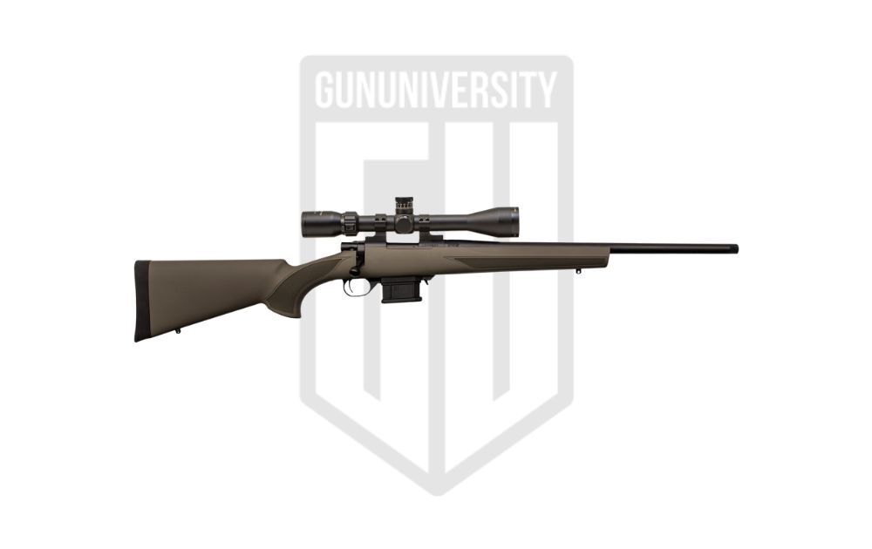

Howa Mini Action 6 ARC

Howa Mini Action Specs
- StockHTI® Synthetic, Pillar-bedded
- Magazine5 or 10-Rounds
- TriggerTwo Stage Match
- Caliber6mm ARC
- Barrel20 inch
- Extractor/EjectorM-16 Style

Howa Mini Action 6 Background
Howa has been making firearms for a long time. Their headquarters in Japan is where they began manufacturing firearms like Arisaka rifles as far back as WWII. They have been making civilian arms for the US market since the 1960’s. As well as making contract parts for US manufacturers like Armalite and others.
The Model 1500 was later released and has become a staple of American hunting rifles, with too many models to mention here.
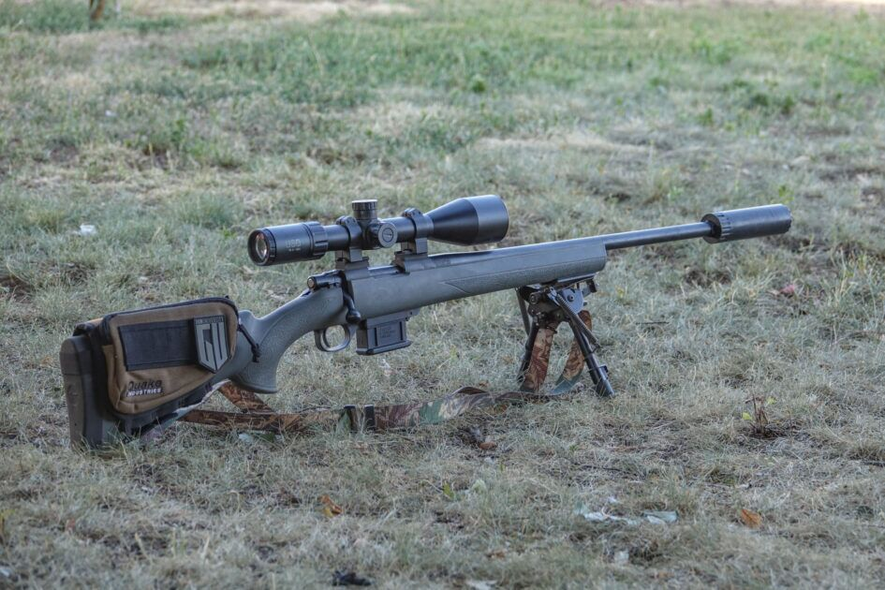
The Mini action was released to the market in 2015, a scaled down version of their very popular Model 1500 action. The Mini is made for .223 sized cartridges only, which makes it ideal for the cartridges listed above.
Howa’s well known affordability brought a lighter and more compact bolt-action rifle to market with a dedicated mini-action for those looking to shoot small cartridges. Since its release, the Mini line has expanded quite a bit, with various configurations.

Howa Mini Action 6 ARC Features
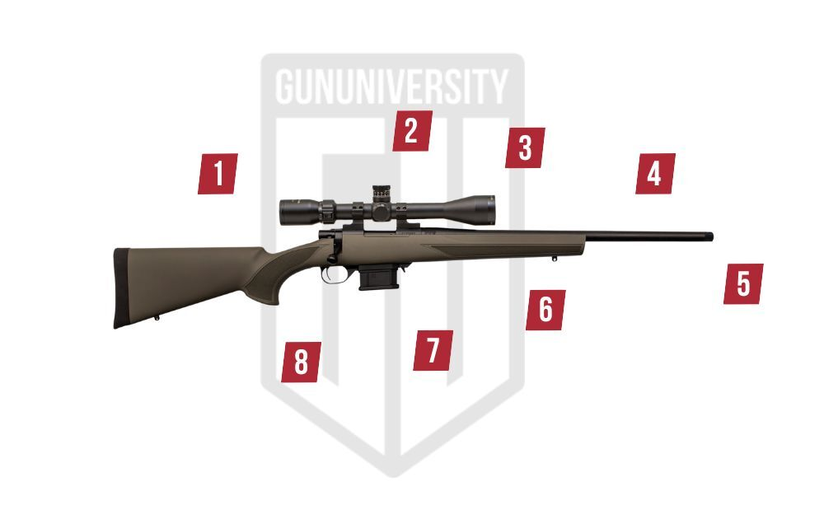

1Howa Mini Action
Very short bolt throw with two lugs

2One-piece bolt
For added strength

3M-16 style extractor
For reliable and secure extraction

4Threaded Muzzle
Allows you to add any muzzle accessories

5Pillar bedded stock
For sturdy and secure action/stock connection

6Three-position safety
With safe bolt locked, safe, and fire

7Detachable box magazine
Five and ten-round magazines available for quick loading

8Two-stage trigger
Match grade two-stage trigger for excellent fire control

Other Models
The Howa Mini is available in three different configurations. The original you see here today, as well as a hydro-dipped version with various full camouflage finishes. There is also a chassis version of the rifle called the Mini EXCL Lite, that uses modern sporting rifle ergonomics. All three different models can be had in the various caliber offerings.

My Thoughts and Review of the Howa Mini
It’s not often that I get to long-term test some of the firearms we review here, but in today’s case I can because I bought this rifle. And in the year or so that we’ve had it, we have given it quite a workout.
Several members of the family have used the little Howa on a multitude of occasions. And if I had to guess, I would put the round count currently around 500 rounds. Many of those shots have been varmint hunting shooting 75 grain Vmax ammunition, and Nosler 80 gr BT’s. The rest have been mostly Hornady Black 105 gr BTHP ammo. My wife used the 105’s to take down a deer last fall, which worked fantastic.
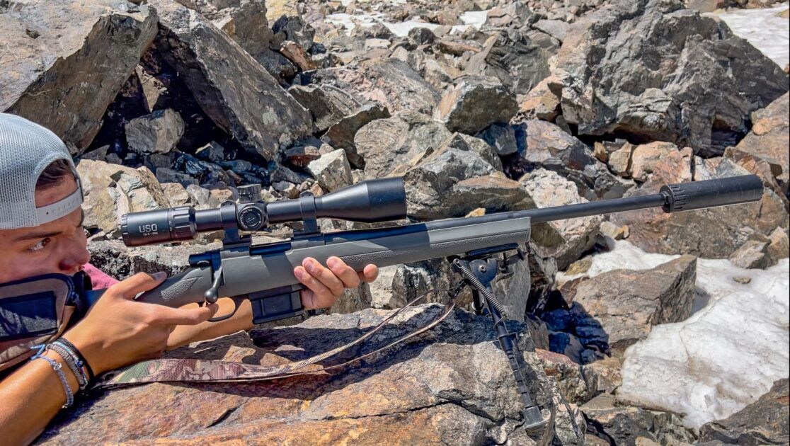
We have shot the rifle suppressed for the most part, using the Yankee hill Machine R9 suppressor. It is ridiculously pleasant to shoot this way, and keeps our prey from getting wise to what’s going on. It also reduces the recoil even further, making it soft enough for a small child to shoot.

Shootability
The Howa Mini has a pretty traditional stock configuration. And for the most part all who have shot it found it to be quite comfortable. The scope mounting configuration ended up a little tall so I added a stock pack to bring things inline.
The controls of the rifle are all very easy to operate and the short-throw of the bolt is great for younger shooters. We don’t often use the safety, but when we do it is nice to keep the bolt locked closed. The magazines, while a little cheap-feeling, have worked flawlessly. And having the mag release at the front of the magwell is a little unorthodox. The two-stage trigger is very impressive for a rifle of this price-point, which resulted in excellent accuracy.

Accuracy
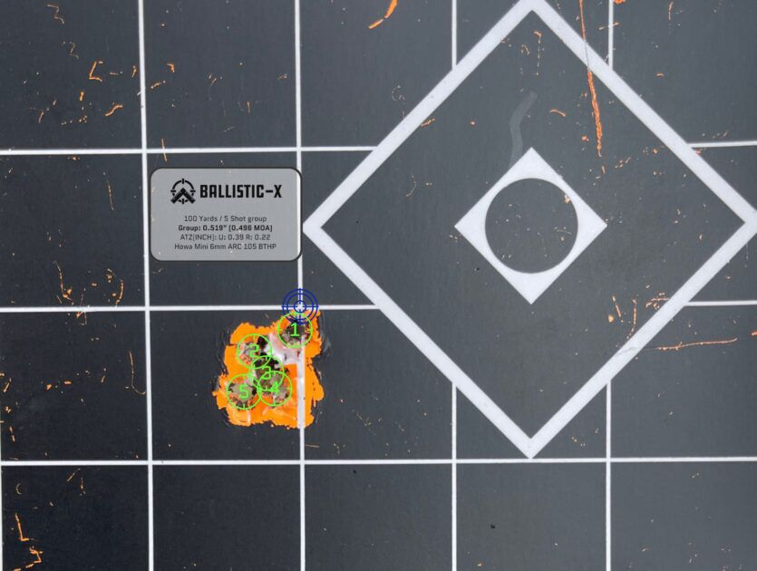
Howa suggests that the Mini shoots sub-MOA accuracy with good ammunition. I found that to be perfectly accurate, but once I started handloading for the rifle it got much better. In fact the hand loaded 105 BTHP from Hornady would typically shoot ½ MOA five-shot groups. Which is pretty impressive for a rifle this affordable.
Factory ammunition would typically only ever shoot MOA for me, the 108 Match from Hornady wasn’t particularly impressive either. But everything I shot through it was good enough for 1-2 MOA. But as you might imagine, I’ve mostly kept to the 105 BTHP hand loads because they shoot so well.

Reliability
In the year or so we’ve been shooting the Howa Mini, I’ve had exactly zero malfunctions. Extraction has always been perfect, and the only problems I could even bring up are the occasional failure to seat the mag completely which results in an empty chamber. We’ve hiked all over these Rocky Mountains in spring, summer, and even deep winter. This little Howa hasn’t been phased at all.
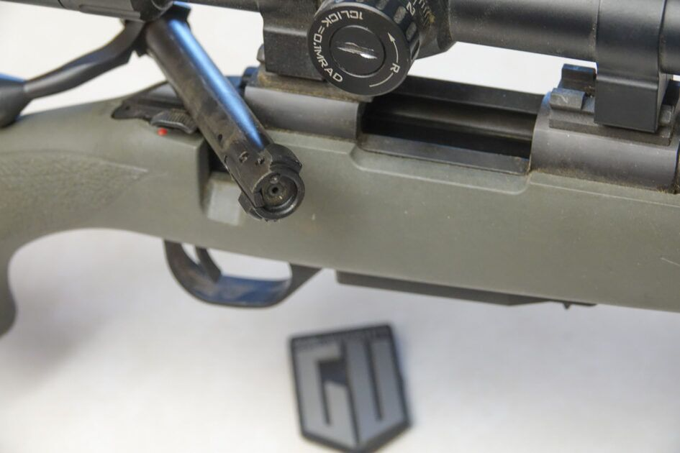

Ergonomics
With a traditional stock design, the ergonomics of the Howa Mini are very familiar. I like having the stock pack in place, but that is just because of the scope height. The gripping areas of the stock are comfortable, and despite being a molded polymer stock it is pretty rigid.

Value
With retail prices under five hundred dollars currently, I believe the Howa Mini is an excellent value. I have paid more for rifles that don’t shoot any better, and don’t have all these features. If you are looking for a compact and inexpensive rifle for plinking or for hunting, this would be at the top of my list.

How Mini Action 6 Pros and Cons
- Excellent accuracy, especially with handholds
- Reliable function
- Threaded muzzle
- Detachable magazines
- Uses Remington 700 scope mounting pattern
- Great suppressor host
- Very affordable
- Broad selection of colors and calibers
- Wish they made an 18-inch 6 ARC
- Magazines feel pretty cheap (but they keep working)
- I wish it had a flush-bottom magazine option

Report Card
Shootability | The Howa Mini feels great and functions exactly like you’d expect a good rifle to | A-
Reliability | After a year of shooting we have had no malfunctions to speak of | A+
Accuracy | Factory ammo certainly meets Howa’s standard, but my hand loads shoot amazing | A
Ergonomics | The Howa Mini stock is comfortable and rigid, above average for poly | A-
Value | I was very happy with the results I paid for, and I would absolutely pay that price again for another | A+
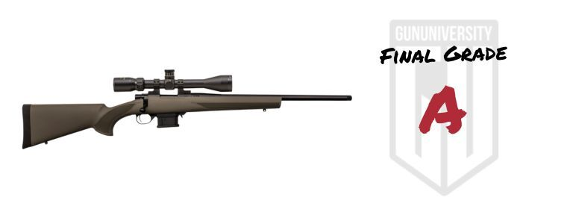

Howa Mini Action 6 ARC

Howa Mini Action 6 – Preferred Ammo
Most 6 ARC ammunition options are from Hornady, and I have tried most of them. My rifle seemed to prefer the Black line with 105 BTHP’s. I’ll again stress that hand loading has given excellent results, and Alpha Munitions is now making 6 ARC brass, so there is lots of support.
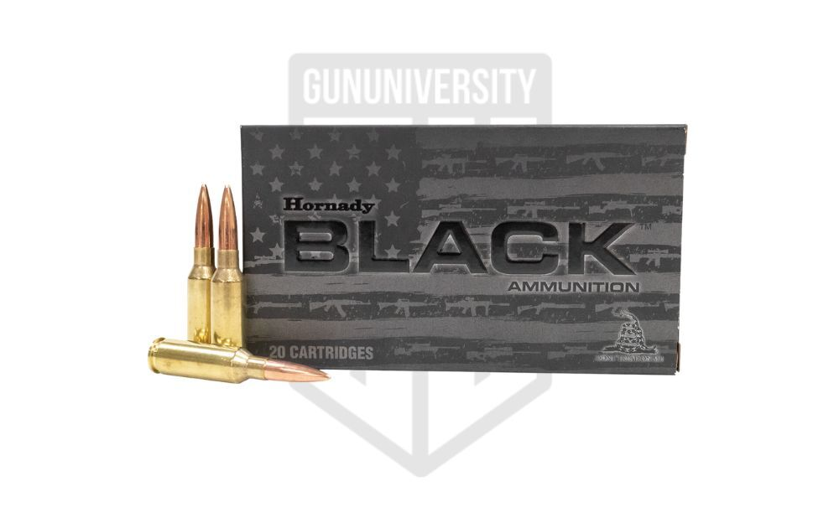

Hornady Black – 105 Grain BTHP
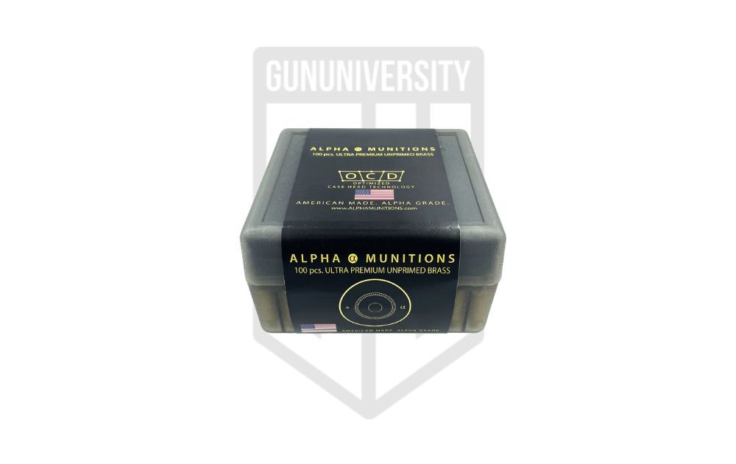

Alpha Munitions 6mm Dasher Brass

Upgrades and Accessories
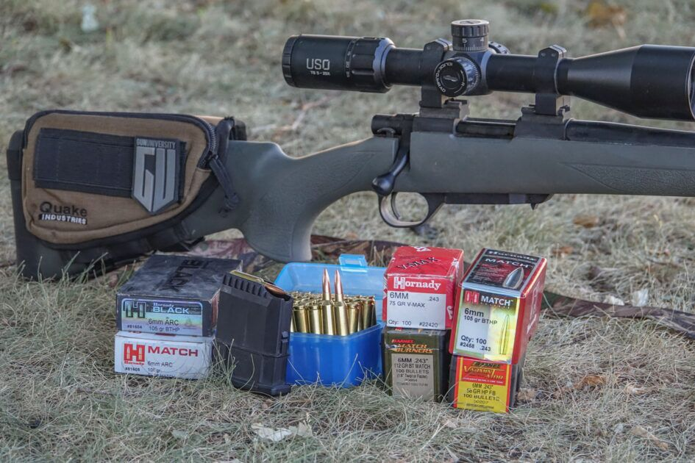
I mounted a US Optics TS25X scope to the Mini, it was a step up from the cheap scope the rifle came with. Using Remington two-piece scope bases and Warne rings. This was a great combination for the little Mini.
We usually kept a sling and bipod on the rifle as well. The bipod of course was a Harris SL model, and a Butler Creek stretchy sling for carrying comfort.
I mentioned using the R9 suppressor from YHM, I would strongly recommend it as an excellent choice for the Howa Mini in any of its calibers.

My Final Thoughts
I have really grown to like this little rifle, its taken a fair share of marmots and prairie dogs, and at least one deer. This year we will be using it again during the deer hunt. The rifle is just too reliably good not to bring it along for my wife and daughter.

I’ve used other comparable guns like the Savage Axis, and the Mossberg Patriot, which both have their strong points. But I would definitely recommend the Howa Mini over those two. I’m tempted to get another Mini chambered in 6.5 Grendel, but we’ll see how that goes. Thanks for reading this far, comment below and tell us what you think of the Howa Mini.

